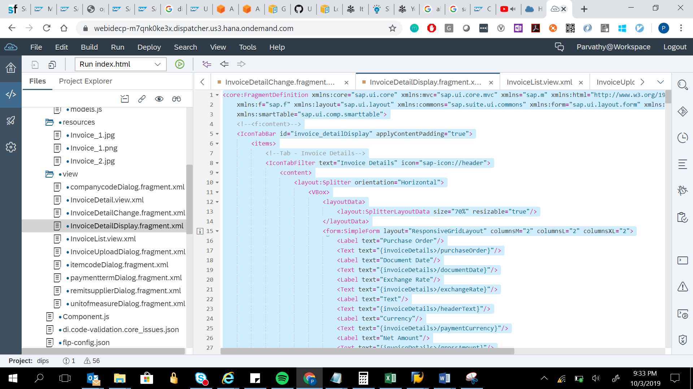

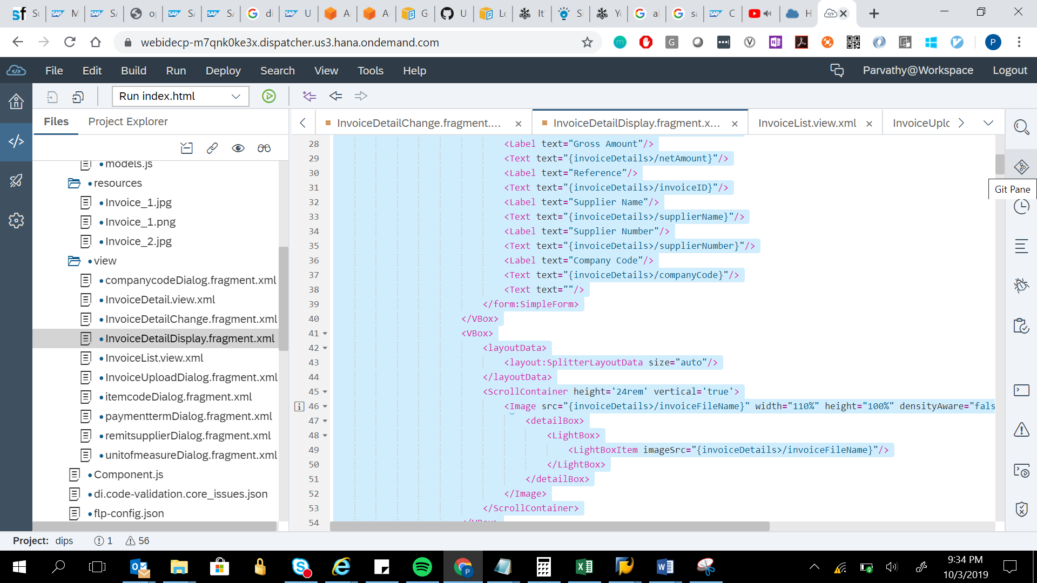

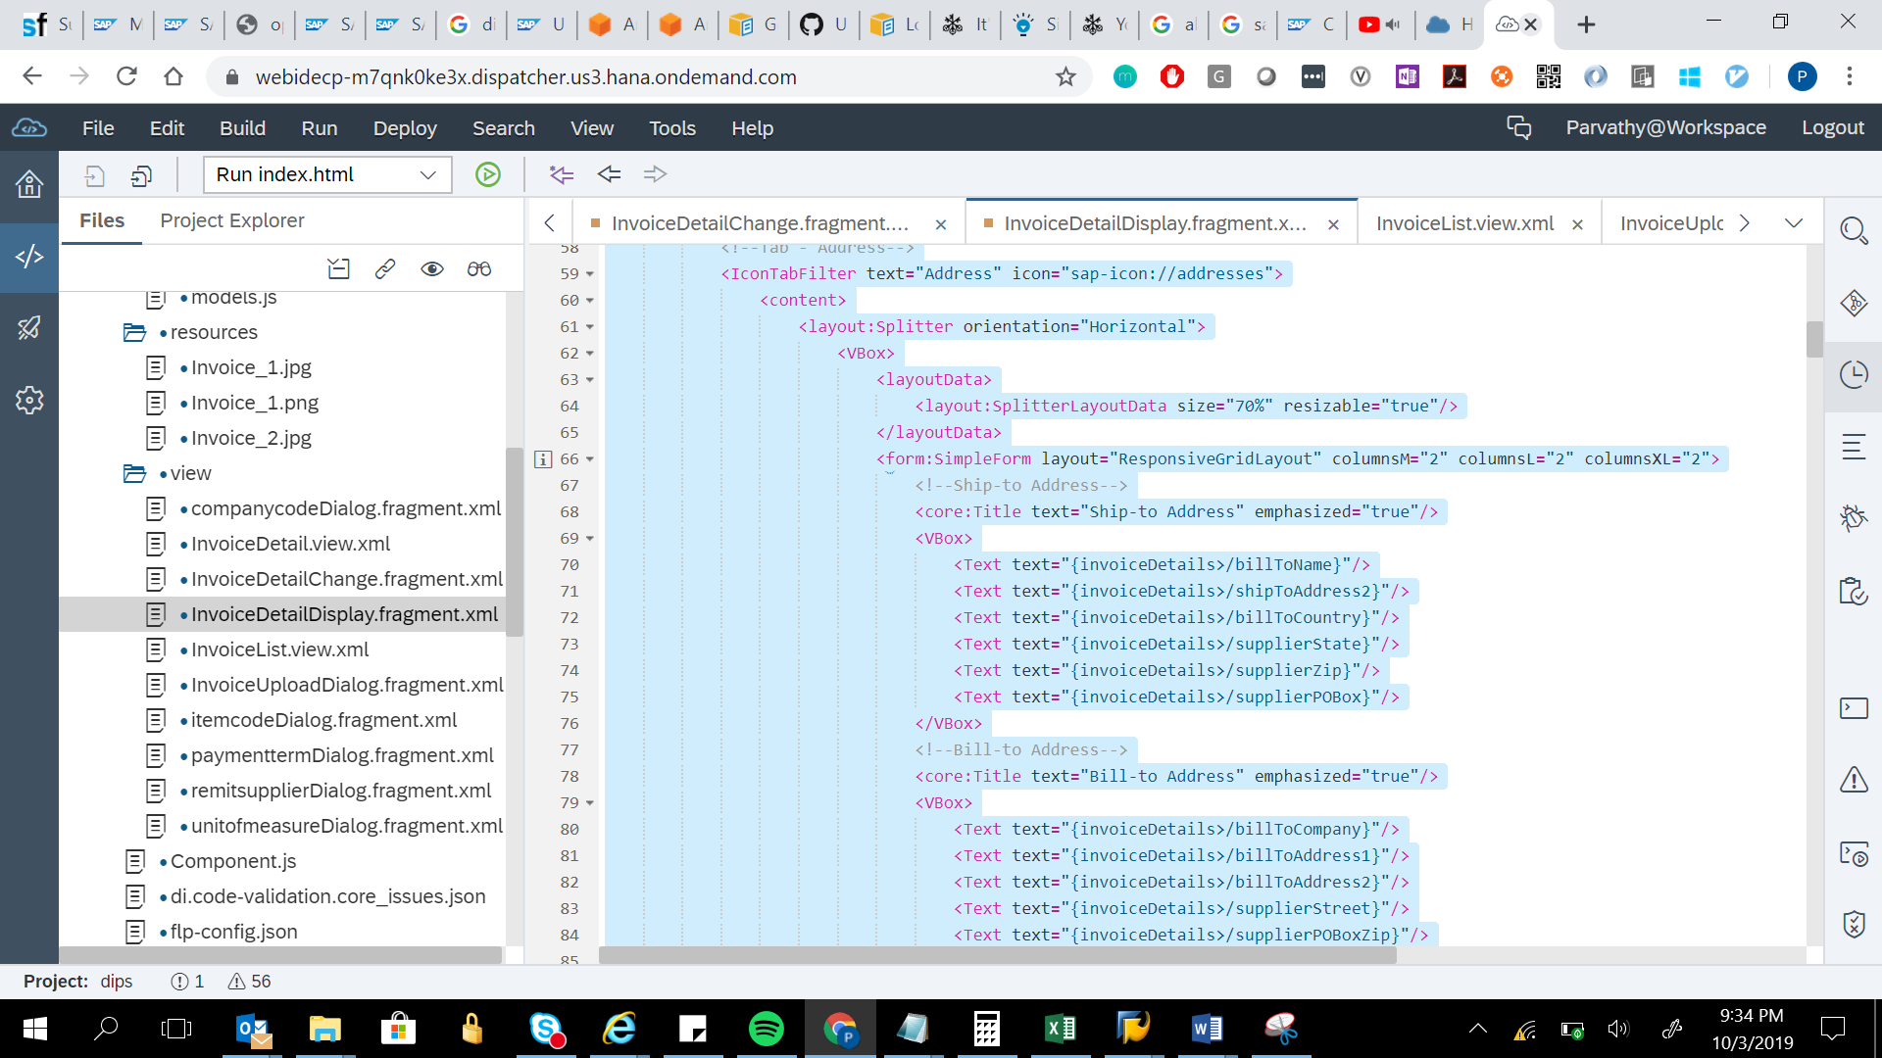

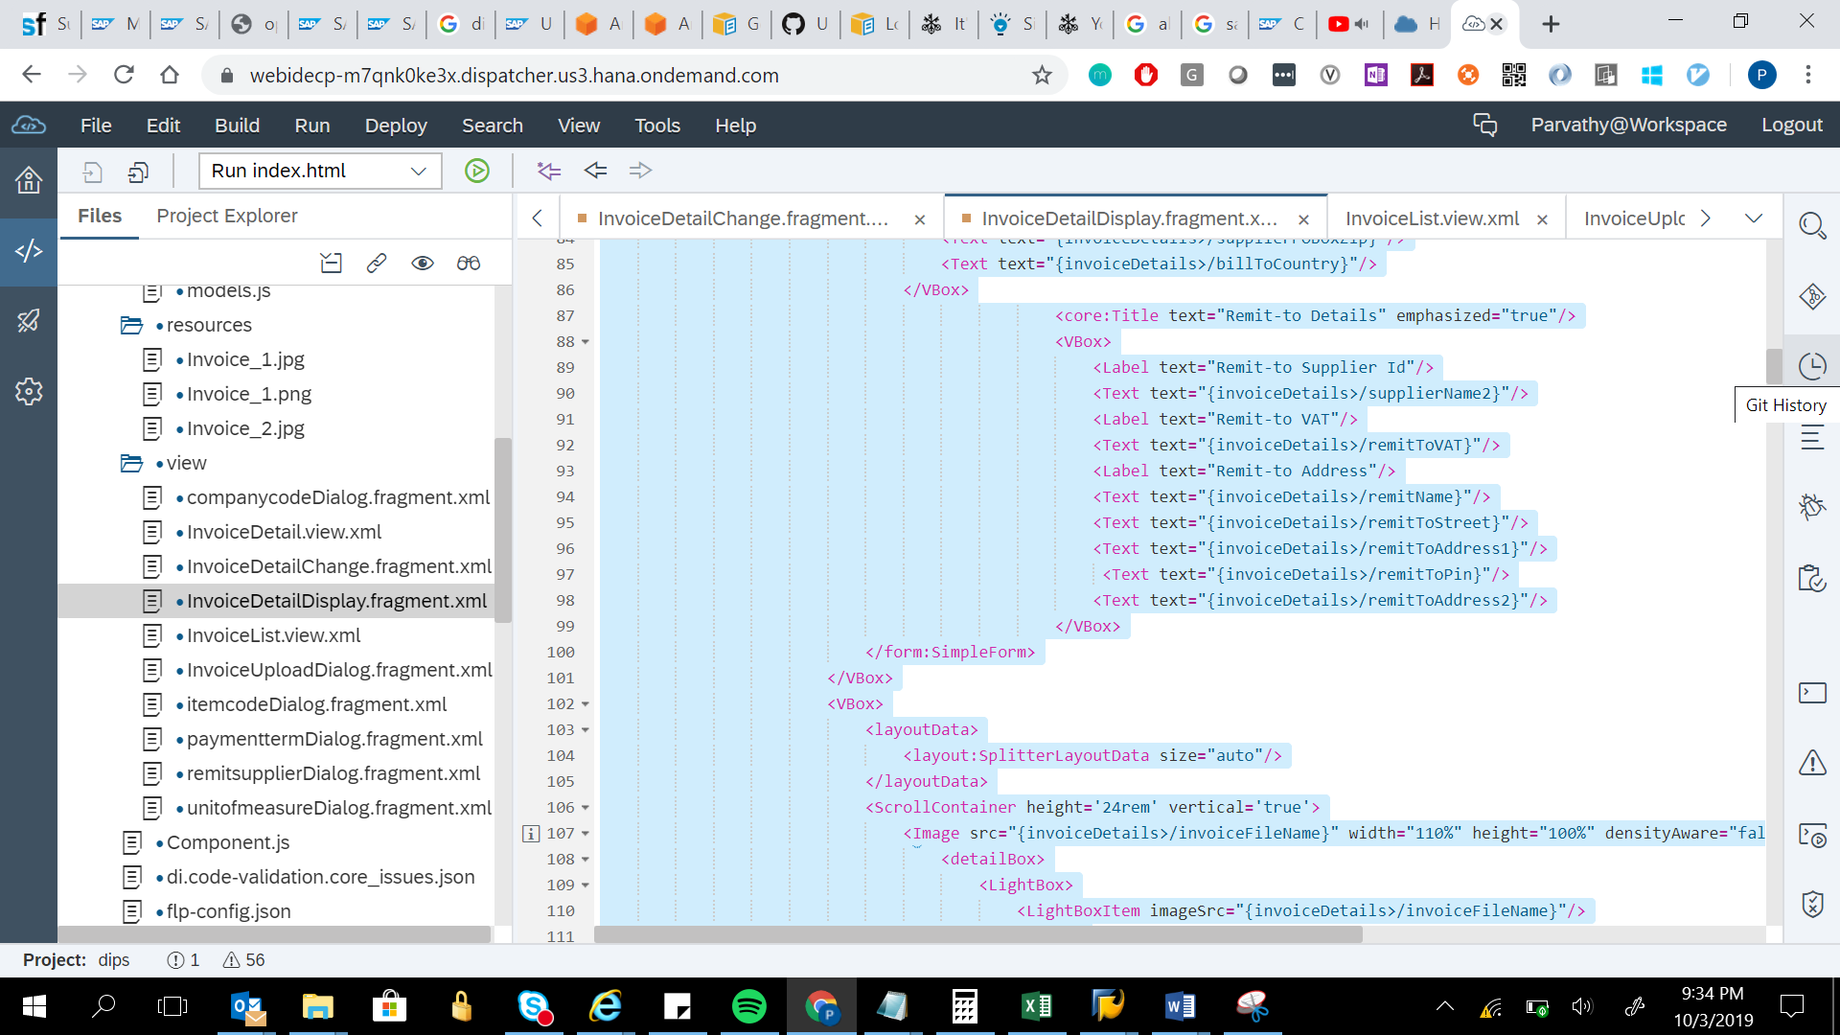

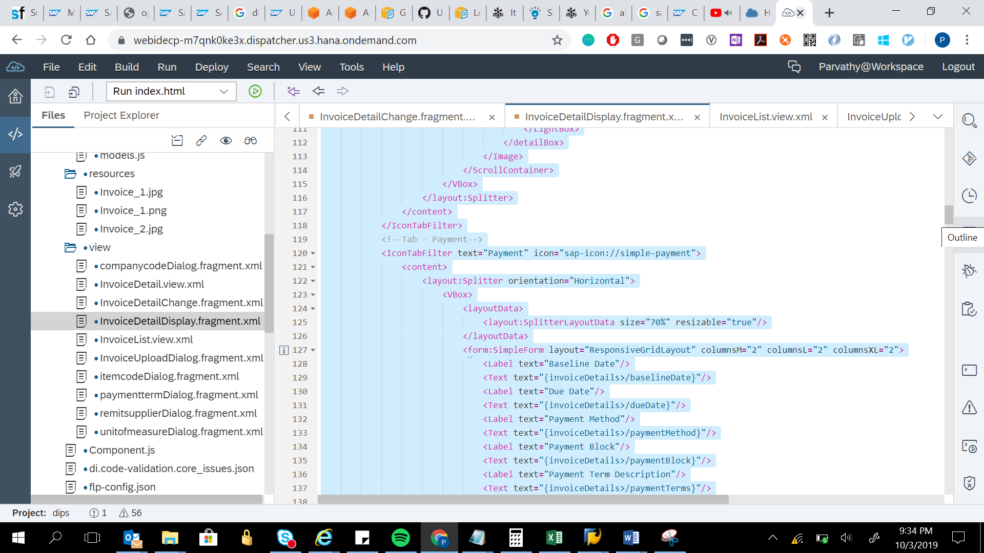

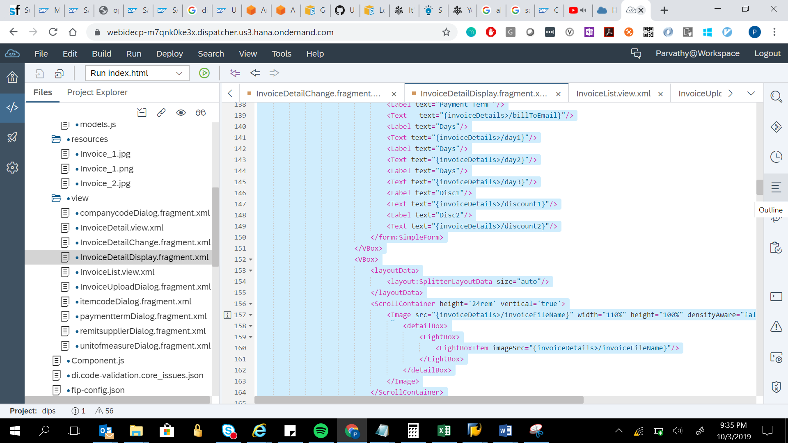

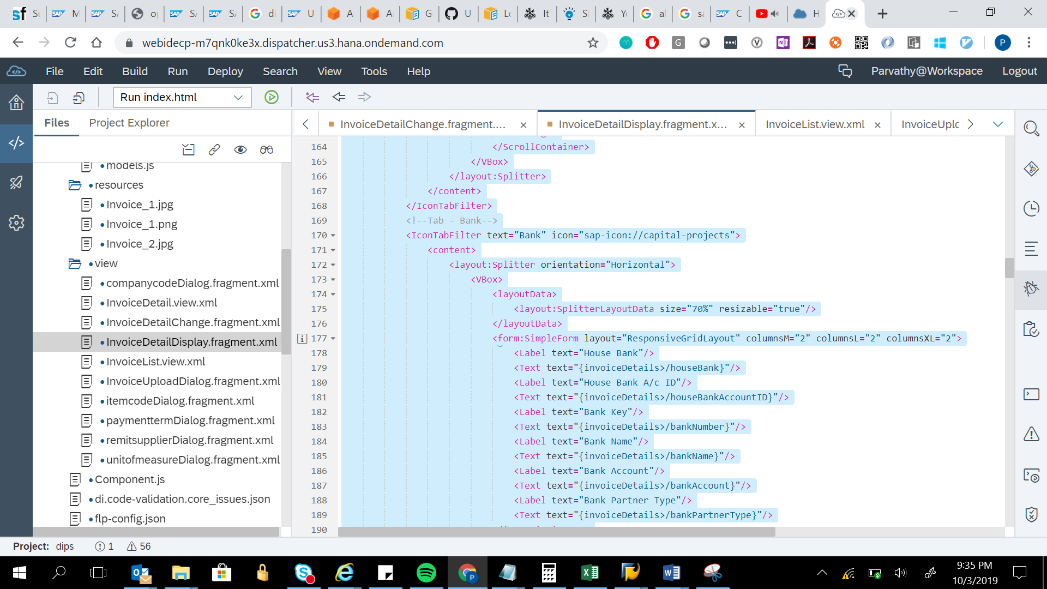

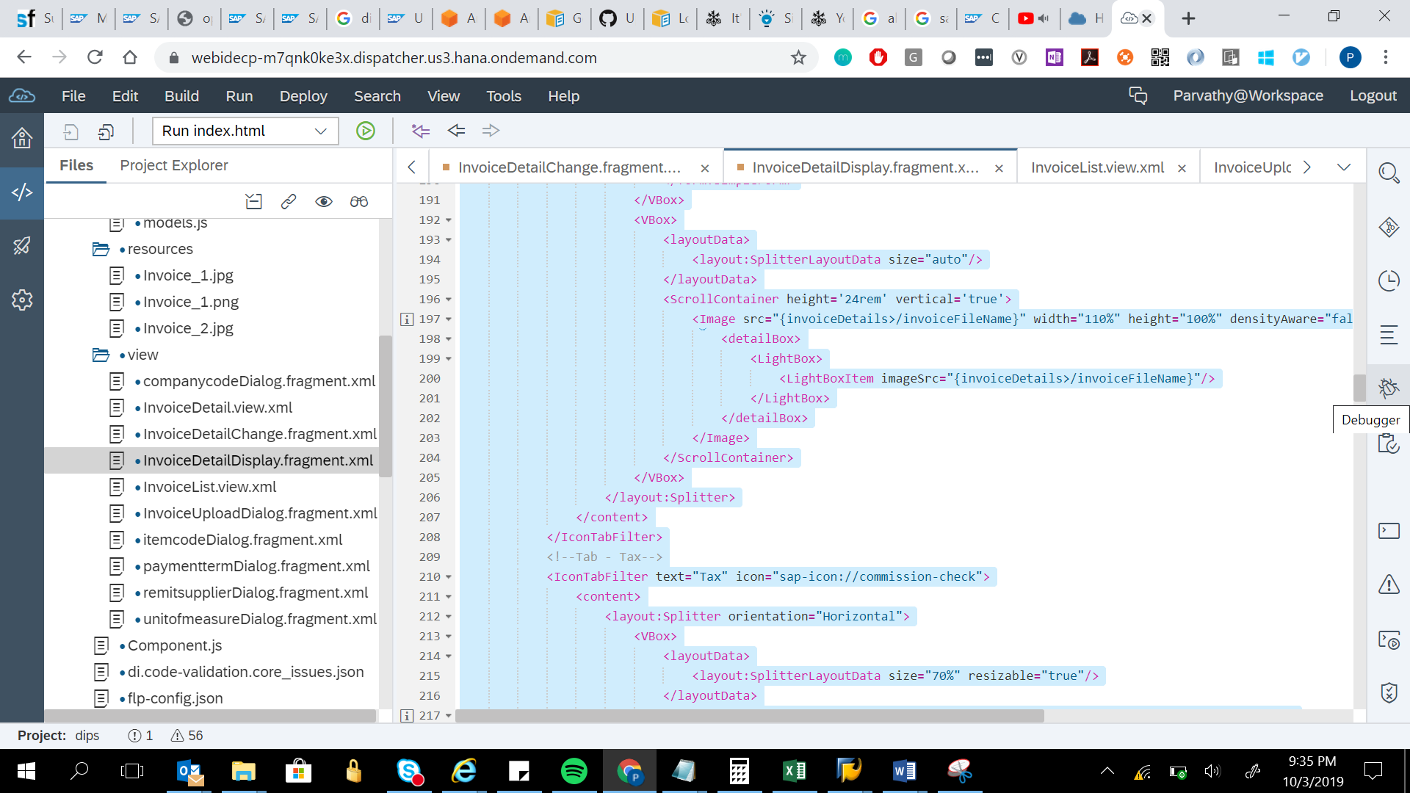

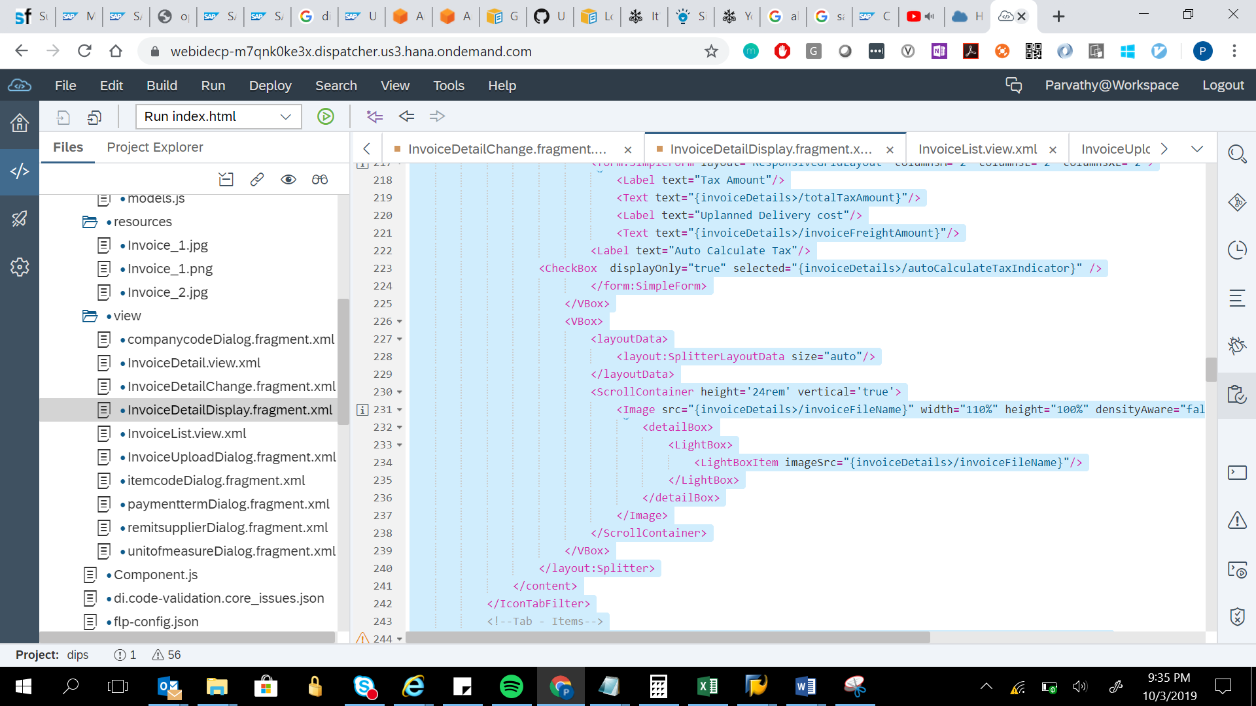

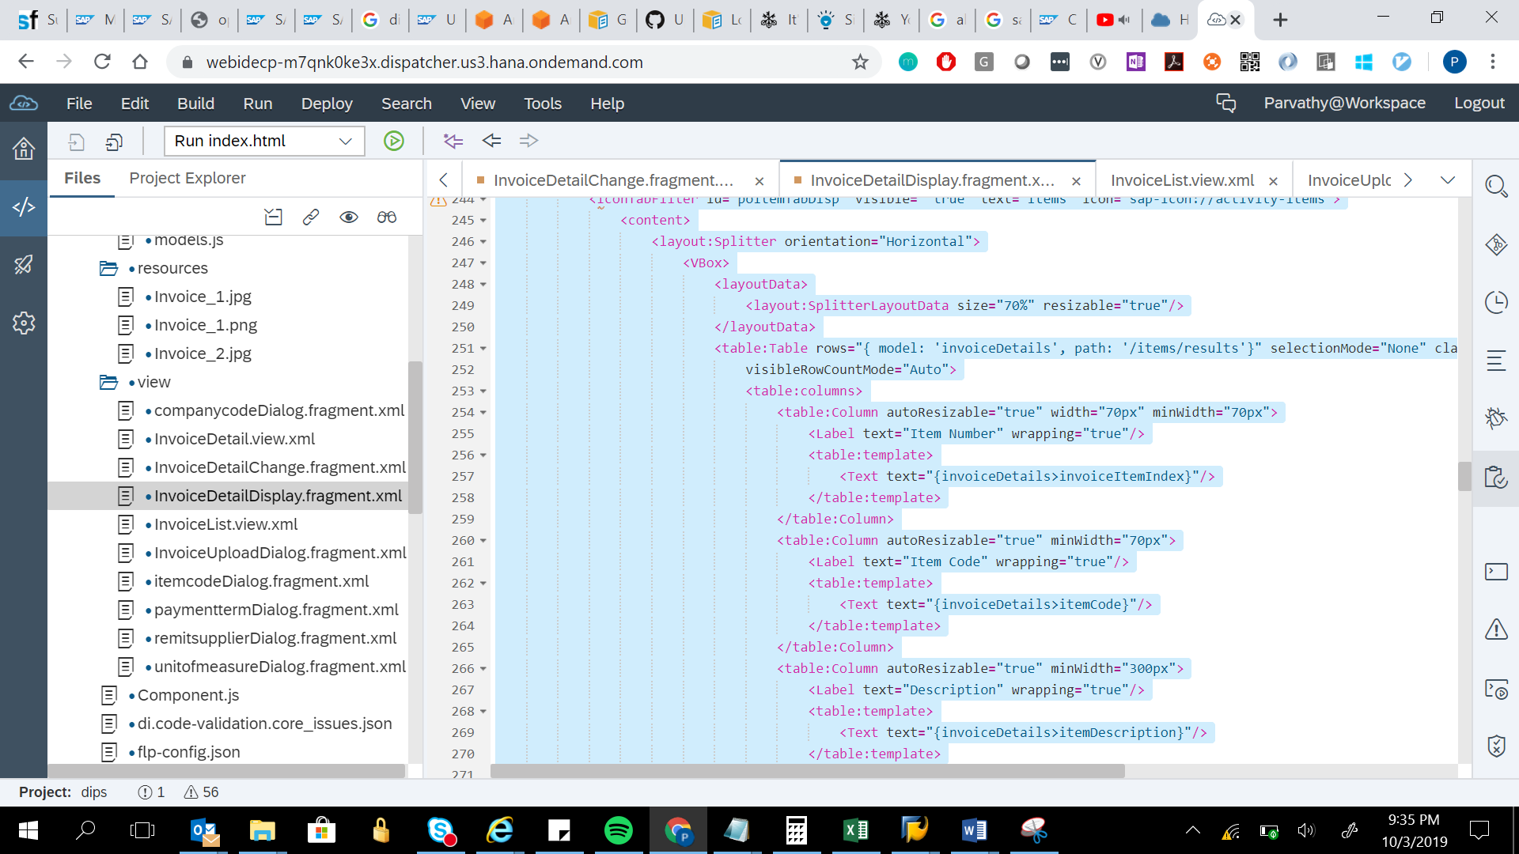

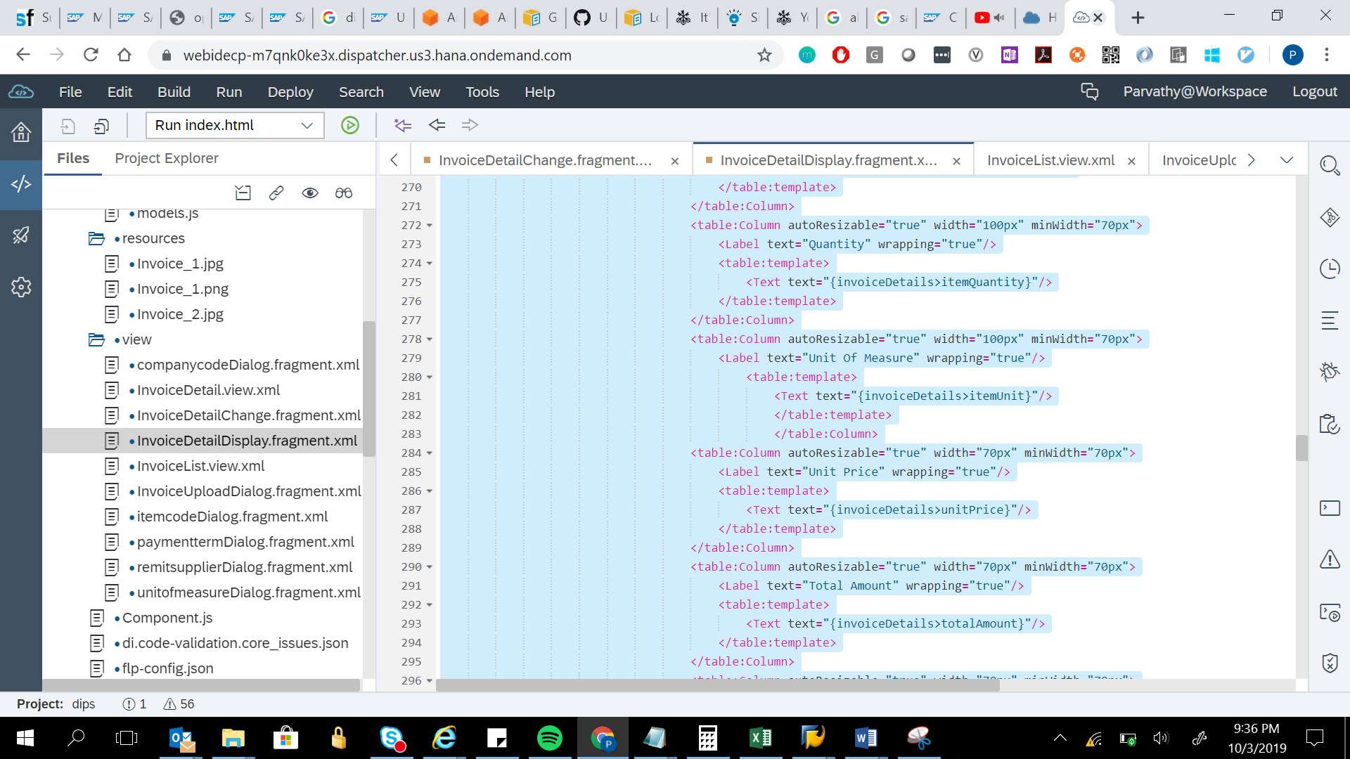

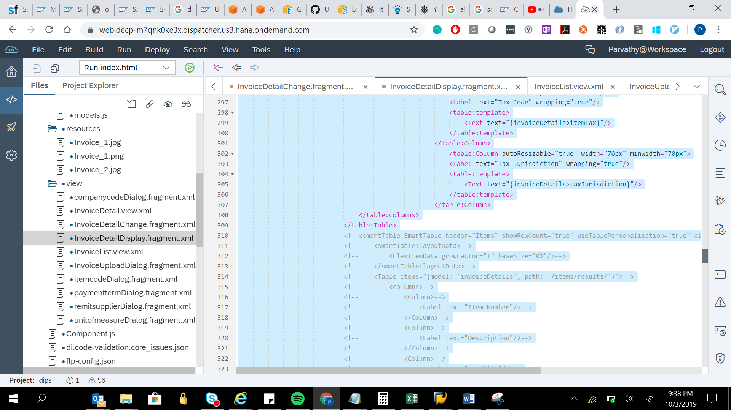

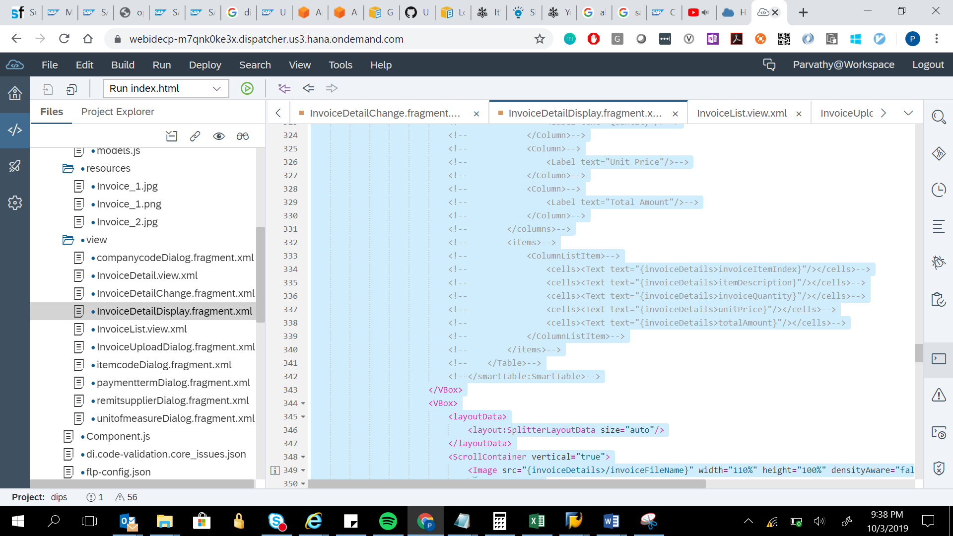

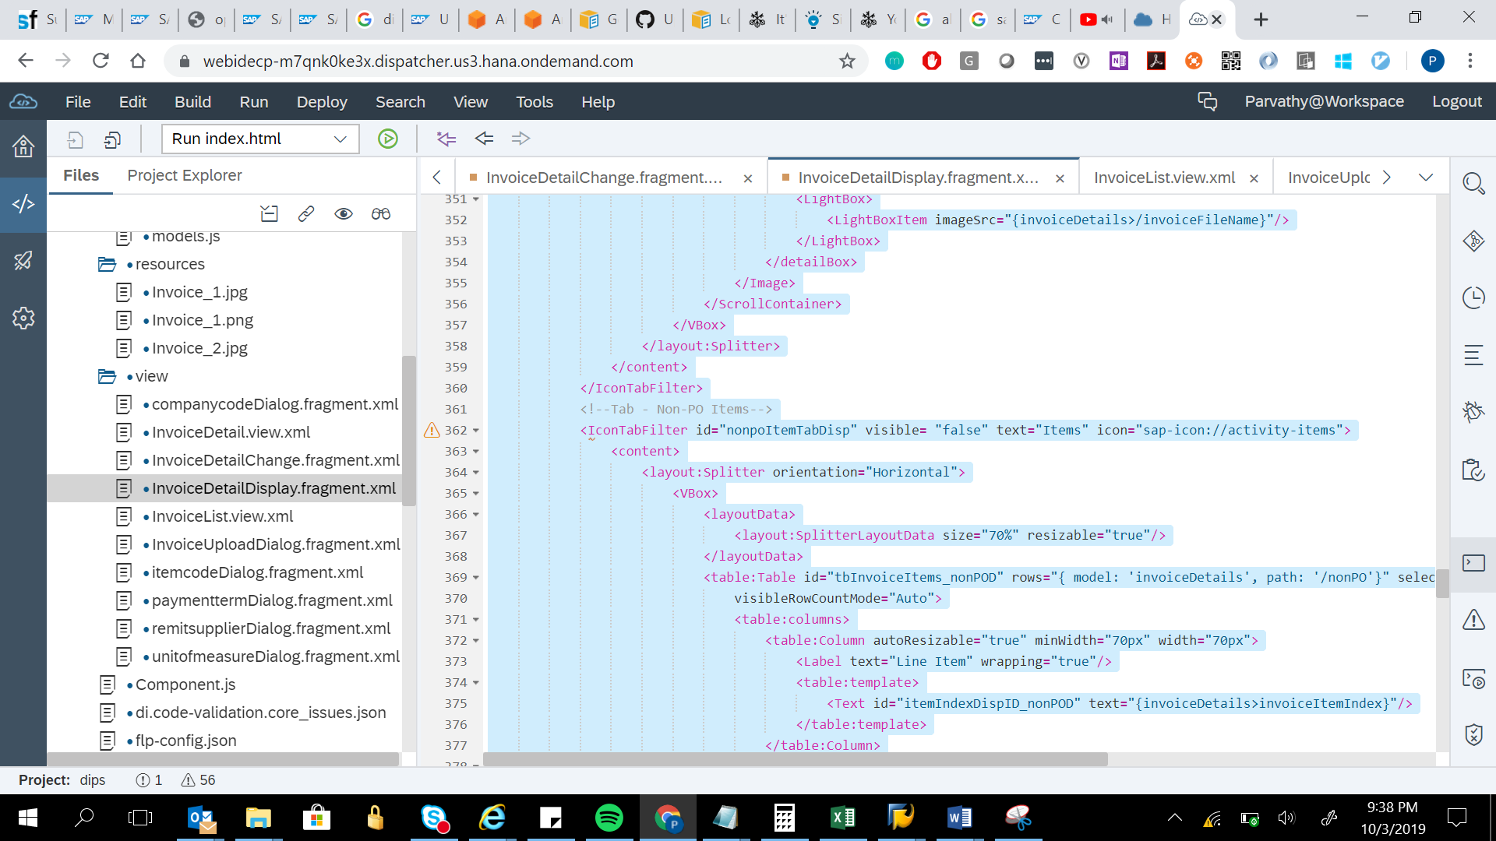

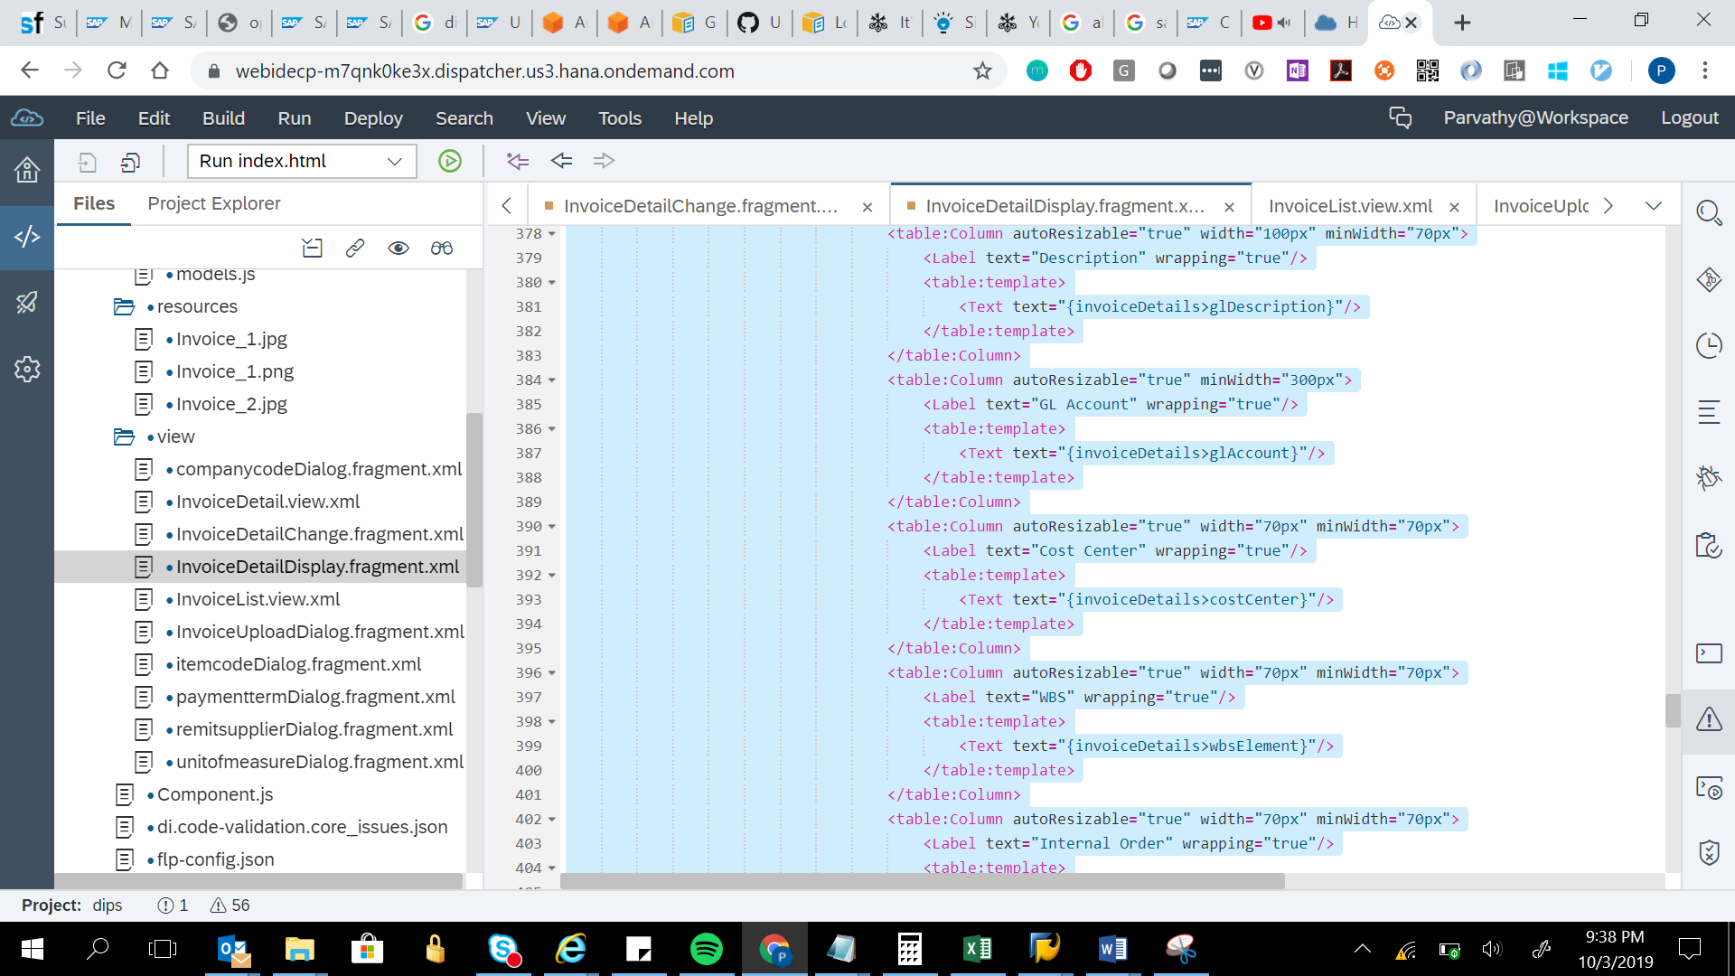

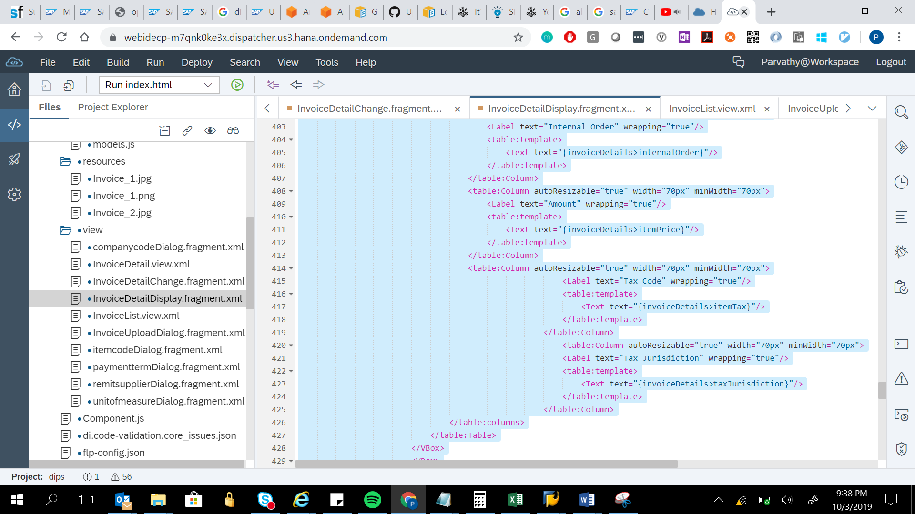

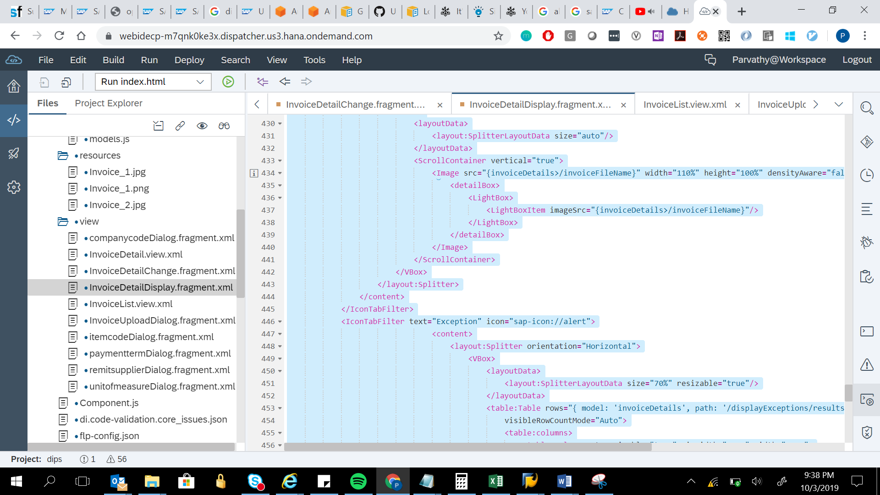

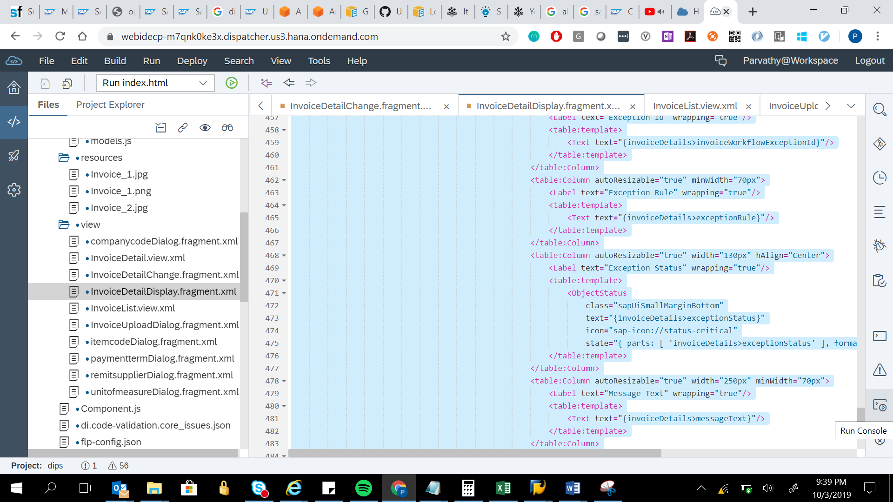

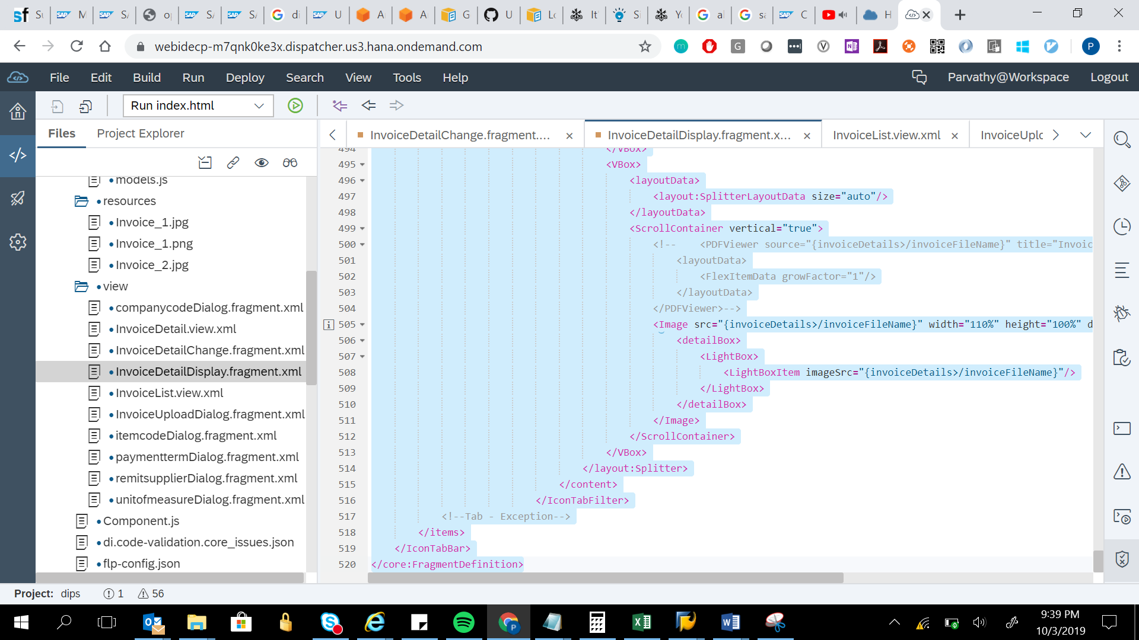

<core:FragmentDefinition xmlns:core="sap.ui.core" xmlns:mvc="sap.ui.core.mvc" xmlns="sap.m" xmlns:html="http://www.w3.org/1999/xhtml"

xmlns:f="sap.f" xmlns:layout="sap.ui.layout" xmlns:commons="sap.suite.ui.commons" xmlns:form="sap.ui.layout.form" xmlns:table="sap.ui.table"

xmlns:smartTable="sap.ui.comp.smarttable">

<!--<f:content>-->

<IconTabBar id="invoice_detailDisplay" applyContentPadding="true">

<items>

<!--Tab - Invoice Details-->

<IconTabFilter text="Invoice Details" icon="sap-icon://header">

<content>

<layout:Splitter orientation="Horizontal">

<VBox>

<layoutData>

<layout:SplitterLayoutData size="70%" resizable="true"/>

</layoutData>

<form:SimpleForm layout="ResponsiveGridLayout" columnsM="2" columnsL="2" columnsXL="2">

<Label text="Purchase Order"/>

<Text text="{invoiceDetails>/purchaseOrder}"/>

<Label text="Document Date"/>

<Text text="{invoiceDetails>/documentDate}"/>

<Label text="Exchange Rate"/>

<Text text="{invoiceDetails>/exchangeRate}"/>

<Label text="Text"/>

<Text text="{invoiceDetails>/headerText}"/>

<Label text="Currency"/>

<Text text="{invoiceDetails>/paymentCurrency}"/>

<Label text="Net Amount"/>

<Text text="{invoiceDetails>/grossAmount}"/>

<Label text="Gross Amount"/>

<Text text="{invoiceDetails>/netAmount}"/>

<Label text="Reference"/>

<Text text="{invoiceDetails>/invoiceID}"/>

<Label text="Supplier Name"/>

<Text text="{invoiceDetails>/supplierName}"/>

<Label text="Supplier Number"/>

<Text text="{invoiceDetails>/supplierNumber}"/>

<Label text="Company Code"/>

<Text text="{invoiceDetails>/companyCode}"/>

<Text text=""/>

</form:SimpleForm>

</VBox>

<VBox>

<layoutData>

<layout:SplitterLayoutData size="auto"/>

</layoutData>

<ScrollContainer height='24rem' vertical='true'>

<Image src="{invoiceDetails>/invoiceFileName}" width="110%" height="100%" densityAware="false">

<detailBox>

<LightBox>

<LightBoxItem imageSrc="{invoiceDetails>/invoiceFileName}"/>

</LightBox>

</detailBox>

</Image>

</ScrollContainer>

</VBox>

</layout:Splitter>

</content>

</IconTabFilter>

<!--Tab - Address-->

<IconTabFilter text="Address" icon="sap-icon://addresses">

<content>

<layout:Splitter orientation="Horizontal">

<VBox>

<layoutData>

<layout:SplitterLayoutData size="70%" resizable="true"/>

</layoutData>

<form:SimpleForm layout="ResponsiveGridLayout" columnsM="2" columnsL="2" columnsXL="2">

<!--Ship-to Address-->

<core:Title text="Ship-to Address" emphasized="true"/>

<VBox>

<Text text="{invoiceDetails>/billToName}"/>

<Text text="{invoiceDetails>/shipToAddress2}"/>

<Text text="{invoiceDetails>/billToCountry}"/>

<Text text="{invoiceDetails>/supplierState}"/>

<Text text="{invoiceDetails>/supplierZip}"/>

<Text text="{invoiceDetails>/supplierPOBox}"/>

</VBox>

<!--Bill-to Address-->

<core:Title text="Bill-to Address" emphasized="true"/>

<VBox>

<Text text="{invoiceDetails>/billToCompany}"/>

<Text text="{invoiceDetails>/billToAddress1}"/>

<Text text="{invoiceDetails>/billToAddress2}"/>

<Text text="{invoiceDetails>/supplierStreet}"/>

<Text text="{invoiceDetails>/supplierPOBoxZip}"/>

<Text text="{invoiceDetails>/billToCountry}"/>

</VBox>

<core:Title text="Remit-to Details" emphasized="true"/>

<VBox>

<Label text="Remit-to Supplier Id"/>

<Text text="{invoiceDetails>/supplierName2}"/>

<Label text="Remit-to VAT"/>

<Text text="{invoiceDetails>/remitToVAT}"/>

<Label text="Remit-to Address"/>

<Text text="{invoiceDetails>/remitName}"/>

<Text text="{invoiceDetails>/remitToStreet}"/>

<Text text="{invoiceDetails>/remitToAddress1}"/>

<Text text="{invoiceDetails>/remitToPin}"/>

<Text text="{invoiceDetails>/remitToAddress2}"/>

</VBox>

</form:SimpleForm>

</VBox>

<VBox>

<layoutData>

<layout:SplitterLayoutData size="auto"/>

</layoutData>

<ScrollContainer height='24rem' vertical='true'>

<Image src="{invoiceDetails>/invoiceFileName}" width="110%" height="100%" densityAware="false">

<detailBox>

<LightBox>

<LightBoxItem imageSrc="{invoiceDetails>/invoiceFileName}"/>

</LightBox>

</detailBox>

</Image>

</ScrollContainer>

</VBox>

</layout:Splitter>

</content>

</IconTabFilter>

<!--Tab - Payment-->

<IconTabFilter text="Payment" icon="sap-icon://simple-payment">

<content>

<layout:Splitter orientation="Horizontal">

<VBox>

<layoutData>

<layout:SplitterLayoutData size="70%" resizable="true"/>

</layoutData>

<form:SimpleForm layout="ResponsiveGridLayout" columnsM="2" columnsL="2" columnsXL="2">

<Label text="Baseline Date"/>

<Text text="{invoiceDetails>/baselineDate}"/>

<Label text="Due Date"/>

<Text text="{invoiceDetails>/dueDate}"/>

<Label text="Payment Method"/>

<Text text="{invoiceDetails>/paymentMethod}"/>

<Label text="Payment Block"/>

<Text text="{invoiceDetails>/paymentBlock}"/>

<Label text="Payment Term Description"/>

<Text text="{invoiceDetails>/paymentTerms}"/>

<Label text="Payment Term "/>

<Text text="{invoiceDetails>/billToEmail}"/>

<Label text="Days"/>

<Text text="{invoiceDetails>/day1}"/>

<Label text="Days"/>

<Text text="{invoiceDetails>/day2}"/>

<Label text="Days"/>

<Text text="{invoiceDetails>/day3}"/>

<Label text="Disc1"/>

<Text text="{invoiceDetails>/discount1}"/>

<Label text="Disc2"/>

<Text text="{invoiceDetails>/discount2}"/>

</form:SimpleForm>

</VBox>

<VBox>

<layoutData>

<layout:SplitterLayoutData size="auto"/>

</layoutData>

<ScrollContainer height='24rem' vertical='true'>

<Image src="{invoiceDetails>/invoiceFileName}" width="110%" height="100%" densityAware="false">

<detailBox>

<LightBox>

<LightBoxItem imageSrc="{invoiceDetails>/invoiceFileName}"/>

</LightBox>

</detailBox>

</Image>

</ScrollContainer>

</VBox>

</layout:Splitter>

</content>

</IconTabFilter>

<!--Tab - Bank-->

<IconTabFilter text="Bank" icon="sap-icon://capital-projects">

<content>

<layout:Splitter orientation="Horizontal">

<VBox>

<layoutData>

<layout:SplitterLayoutData size="70%" resizable="true"/>

</layoutData>

<form:SimpleForm layout="ResponsiveGridLayout" columnsM="2" columnsL="2" columnsXL="2">

<Label text="House Bank"/>

<Text text="{invoiceDetails>/houseBank}"/>

<Label text="House Bank A/c ID"/>

<Text text="{invoiceDetails>/houseBankAccountID}"/>

<Label text="Bank Key"/>

<Text text="{invoiceDetails>/bankNumber}"/>

<Label text="Bank Name"/>

<Text text="{invoiceDetails>/bankName}"/>

<Label text="Bank Account"/>

<Text text="{invoiceDetails>/bankAccount}"/>

<Label text="Bank Partner Type"/>

<Text text="{invoiceDetails>/bankPartnerType}"/>

</form:SimpleForm>

</VBox>

<VBox>

<layoutData>

<layout:SplitterLayoutData size="auto"/>

</layoutData>

<ScrollContainer height='24rem' vertical='true'>

<Image src="{invoiceDetails>/invoiceFileName}" width="110%" height="100%" densityAware="false">

<detailBox>

<LightBox>

<LightBoxItem imageSrc="{invoiceDetails>/invoiceFileName}"/>

</LightBox>

</detailBox>

</Image>

</ScrollContainer>

</VBox>

</layout:Splitter>

</content>

</IconTabFilter>

<!--Tab - Tax-->

<IconTabFilter text="Tax" icon="sap-icon://commission-check">

<content>

<layout:Splitter orientation="Horizontal">

<VBox>

<layoutData>

<layout:SplitterLayoutData size="70%" resizable="true"/>

</layoutData>

<form:SimpleForm layout="ResponsiveGridLayout" columnsM="2" columnsL="2" columnsXL="2">

<Label text="Tax Amount"/>

<Text text="{invoiceDetails>/totalTaxAmount}"/>

<Label text="Uplanned Delivery cost"/>

<Text text="{invoiceDetails>/invoiceFreightAmount}"/>

<Label text="Auto Calculate Tax"/>

<CheckBox displayOnly="true" selected="{invoiceDetails>/autoCalculateTaxIndicator}" />

</form:SimpleForm>

</VBox>

<VBox>

<layoutData>

<layout:SplitterLayoutData size="auto"/>

</layoutData>

<ScrollContainer height='24rem' vertical='true'>

<Image src="{invoiceDetails>/invoiceFileName}" width="110%" height="100%" densityAware="false">

<detailBox>

<LightBox>

<LightBoxItem imageSrc="{invoiceDetails>/invoiceFileName}"/>

</LightBox>

</detailBox>

</Image>

</ScrollContainer>

</VBox>

</layout:Splitter>

</content>

</IconTabFilter>

<!--Tab - Items-->

<IconTabFilter id="poItemTabDisp" visible= "true" text="Items" icon="sap-icon://activity-items">

<content>

<layout:Splitter orientation="Horizontal">

<VBox>

<layoutData>

<layout:SplitterLayoutData size="70%" resizable="true"/>

</layoutData>

<table:Table rows="{ model: 'invoiceDetails', path: '/items/results'}" selectionMode="None" class="sapUiSmallMarginEnd"

visibleRowCountMode="Auto">

<table:columns>

<table:Column autoResizable="true" width="70px" minWidth="70px">

<Label text="Item Number" wrapping="true"/>

<table:template>

<Text text="{invoiceDetails>invoiceItemIndex}"/>

</table:template>

</table:Column>

<table:Column autoResizable="true" minWidth="70px">

<Label text="Item Code" wrapping="true"/>

<table:template>

<Text text="{invoiceDetails>itemCode}"/>

</table:template>

</table:Column>

<table:Column autoResizable="true" minWidth="300px">

<Label text="Description" wrapping="true"/>

<table:template>

<Text text="{invoiceDetails>itemDescription}"/>

</table:template>

</table:Column>

<table:Column autoResizable="true" width="100px" minWidth="70px">

<Label text="Quantity" wrapping="true"/>

<table:template>

<Text text="{invoiceDetails>itemQuantity}"/>

</table:template>

</table:Column>

<table:Column autoResizable="true" width="100px" minWidth="70px">

<Label text="Unit Of Measure" wrapping="true"/>

<table:template>

<Text text="{invoiceDetails>itemUnit}"/>

</table:template>

</table:Column>

<table:Column autoResizable="true" width="70px" minWidth="70px">

<Label text="Unit Price" wrapping="true"/>

<table:template>

<Text text="{invoiceDetails>unitPrice}"/>

</table:template>

</table:Column>

<table:Column autoResizable="true" width="70px" minWidth="70px">

<Label text="Total Amount" wrapping="true"/>

<table:template>

<Text text="{invoiceDetails>totalAmount}"/>

</table:template>

</table:Column>

<table:Column autoResizable="true" width="70px" minWidth="70px">

<Label text="Tax Code" wrapping="true"/>

<table:template>

<Text text="{invoiceDetails>itemTax}"/>

</table:template>

</table:Column>

<table:Column autoResizable="true" width="70px" minWidth="70px">

<Label text="Tax Jurisdiction" wrapping="true"/>

<table:template>

<Text text="{invoiceDetails>taxJurisdiction}"/>

</table:template>

</table:Column>

</table:columns>

</table:Table>

<!--<smartTable:SmartTable header="Items" showRowCount="true" useTablePersonalisation="true" class="sapUiResponsiveContentPadding">-->

<!-- <smartTable:layoutData>-->

<!-- <FlexItemData growFactor="1" baseSize="0%"/>-->

<!-- </smartTable:layoutData>-->

<!-- <Table items="{model: 'invoiceDetails', path: '/items/results/'}">-->

<!-- <columns>-->

<!-- <Column>-->

<!-- <Label text="Item Number"/>-->

<!-- </Column>-->

<!-- <Column>-->

<!-- <Label text="Description"/>-->

<!-- </Column>-->

<!-- <Column>-->

<!-- <Label text="Quantity"/>-->

<!-- </Column>-->

<!-- <Column>-->

<!-- <Label text="Unit Price"/>-->

<!-- </Column>-->

<!-- <Column>-->

<!-- <Label text="Total Amount"/>-->

<!-- </Column>-->

<!-- </columns>-->

<!-- <items>-->

<!-- <ColumnListItem>-->

<!-- <cells><Text text="{invoiceDetails>invoiceItemIndex}"/></cells>-->

<!-- <cells><Text text="{invoiceDetails>itemDescription}"/></cells>-->

<!-- <cells><Text text="{invoiceDetails>invoiceQuantity}"/></cells>-->

<!-- <cells><Text text="{invoiceDetails>unitPrice}"/></cells>-->

<!-- <cells><Text text="{invoiceDetails>totalAmount}"/></cells>-->

<!-- </ColumnListItem>-->

<!-- </items>-->

<!-- </Table>-->

<!--</smartTable:SmartTable>-->

</VBox>

<VBox>

<layoutData>

<layout:SplitterLayoutData size="auto"/>

</layoutData>

<ScrollContainer vertical="true">

<Image src="{invoiceDetails>/invoiceFileName}" width="110%" height="100%" densityAware="false">

<detailBox>

<LightBox>

<LightBoxItem imageSrc="{invoiceDetails>/invoiceFileName}"/>

</LightBox>

</detailBox>

</Image>

</ScrollContainer>

</VBox>

</layout:Splitter>

</content>

</IconTabFilter>

<!--Tab - Non-PO Items-->

<IconTabFilter id="nonpoItemTabDisp" visible= "false" text="Items" icon="sap-icon://activity-items">

<content>

<layout:Splitter orientation="Horizontal">

<VBox>

<layoutData>

<layout:SplitterLayoutData size="70%" resizable="true"/>

</layoutData>

<table:Table id="tbInvoiceItems_nonPOD" rows="{ model: 'invoiceDetails', path: '/nonPO'}" selectionMode="None" class="sapUiSmallMarginEnd"

visibleRowCountMode="Auto">

<table:columns>

<table:Column autoResizable="true" minWidth="70px" width="70px">

<Label text="Line Item" wrapping="true"/>

<table:template>

<Text id="itemIndexDispID_nonPOD" text="{invoiceDetails>invoiceItemIndex}"/>

</table:template>

</table:Column>

<table:Column autoResizable="true" width="100px" minWidth="70px">

<Label text="Description" wrapping="true"/>

<table:template>

<Text text="{invoiceDetails>glDescription}"/>

</table:template>

</table:Column>

<table:Column autoResizable="true" minWidth="300px">

<Label text="GL Account" wrapping="true"/>

<table:template>

<Text text="{invoiceDetails>glAccount}"/>

</table:template>

</table:Column>

<table:Column autoResizable="true" width="70px" minWidth="70px">

<Label text="Cost Center" wrapping="true"/>

<table:template>

<Text text="{invoiceDetails>costCenter}"/>

</table:template>

</table:Column>

<table:Column autoResizable="true" width="70px" minWidth="70px">

<Label text="WBS" wrapping="true"/>

<table:template>

<Text text="{invoiceDetails>wbsElement}"/>

</table:template>

</table:Column>

<table:Column autoResizable="true" width="70px" minWidth="70px">

<Label text="Internal Order" wrapping="true"/>

<table:template>

<Text text="{invoiceDetails>internalOrder}"/>

</table:template>

</table:Column>

<table:Column autoResizable="true" width="70px" minWidth="70px">

<Label text="Amount" wrapping="true"/>

<table:template>

<Text text="{invoiceDetails>itemPrice}"/>

</table:template>

</table:Column>

<table:Column autoResizable="true" width="70px" minWidth="70px">

<Label text="Tax Code" wrapping="true"/>

<table:template>

<Text text="{invoiceDetails>itemTax}"/>

</table:template>

</table:Column>

<table:Column autoResizable="true" width="70px" minWidth="70px">

<Label text="Tax Jurisdiction" wrapping="true"/>

<table:template>

<Text text="{invoiceDetails>taxJurisdiction}"/>

</table:template>

</table:Column>

</table:columns>

</table:Table>

</VBox>

<VBox>

<layoutData>

<layout:SplitterLayoutData size="auto"/>

</layoutData>

<ScrollContainer vertical="true">

<Image src="{invoiceDetails>/invoiceFileName}" width="110%" height="100%" densityAware="false">

<detailBox>

<LightBox>

<LightBoxItem imageSrc="{invoiceDetails>/invoiceFileName}"/>

</LightBox>

</detailBox>

</Image>

</ScrollContainer>

</VBox>

</layout:Splitter>

</content>

</IconTabFilter>

<IconTabFilter text="Exception" icon="sap-icon://alert">

<content>

<layout:Splitter orientation="Horizontal">

<VBox>

<layoutData>

<layout:SplitterLayoutData size="70%" resizable="true"/>

</layoutData>

<table:Table rows="{ model: 'invoiceDetails', path: '/displayExceptions/results/'}" selectionMode="None" class="sapUiSmallMarginEnd"

visibleRowCountMode="Auto">

<table:columns>

<table:Column autoResizable="true" minWidth="70px" width="70px">

<Label text="Exception Id" wrapping="true"/>

<table:template>

<Text text="{invoiceDetails>invoiceWorkflowExceptionId}"/>

</table:template>

</table:Column>

<table:Column autoResizable="true" minWidth="70px">

<Label text="Exception Rule" wrapping="true"/>

<table:template>

<Text text="{invoiceDetails>exceptionRule}"/>

</table:template>

</table:Column>

<table:Column autoResizable="true" width="130px" hAlign="Center">

<Label text="Exception Status" wrapping="true"/>

<table:template>

<ObjectStatus

class="sapUiSmallMarginBottom"

text="{invoiceDetails>exceptionStatus}"

icon="sap-icon://status-critical"

state="{ parts: [ 'invoiceDetails>exceptionStatus' ], formatter: '.toTitleCalse' }" />

</table:template>

</table:Column>

<table:Column autoResizable="true" width="250px" minWidth="70px">

<Label text="Message Text" wrapping="true"/>

<table:template>

<Text text="{invoiceDetails>messageText}"/>

</table:template>

</table:Column>

<table:Column autoResizable="true" width="130px" minWidth="70px" hAlign="Center">

<Label text="Applicable to Bypass" wrapping="true"/>

<table:template>

<CheckBox enabled="false" selected="{invoiceDetails>userbypassStatus}" >

</CheckBox>

</table:template>

</table:Column>

</table:columns>

</table:Table>

<Button type="Emphasized" text="Assign" visible="{= ${invoiceDetails>/userRole}===''}" enabled="false" press="onAssignExcetionsPress" icon=""/>

</VBox>

<VBox>

<layoutData>

<layout:SplitterLayoutData size="auto"/>

</layoutData>

<ScrollContainer vertical="true">

<!-- <PDFViewer source="{invoiceDetails>/invoiceFileName}" title="Invoice" height="100%">

<layoutData>

<FlexItemData growFactor="1"/>

</layoutData>

</PDFViewer>-->

<Image src="{invoiceDetails>/invoiceFileName}" width="110%" height="100%" densityAware="false">

<detailBox>

<LightBox>

<LightBoxItem imageSrc="{invoiceDetails>/invoiceFileName}"/>

</LightBox>

</detailBox>

</Image>

</ScrollContainer>

</VBox>

</layout:Splitter>

</content>

</IconTabFilter>

<!--Tab - Exception-->

</items>

</IconTabBar>

</core:FragmentDefinition>